**Deadlock Example [1]**

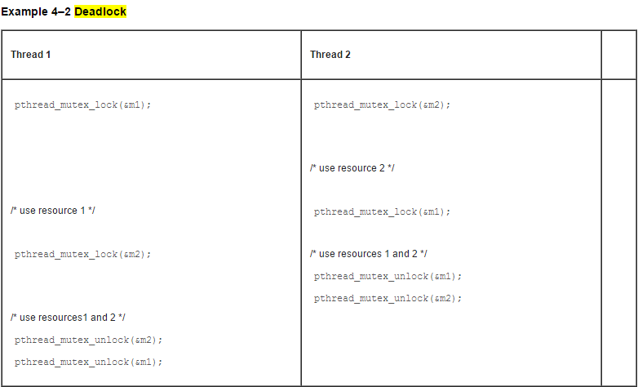

**Race Condition Example [2]**

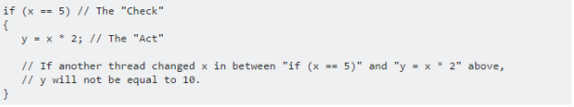

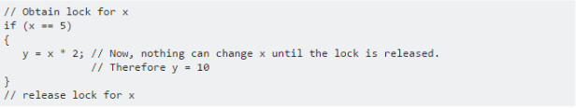

**Order Violation Example [3]**

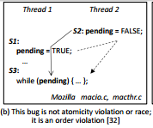

**Missed Signal Example [4]**

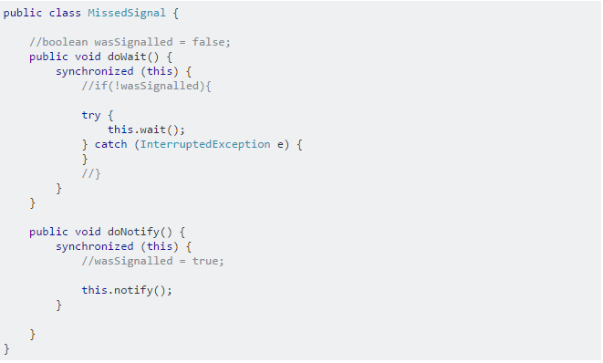

**Atomicity Violation [5]**

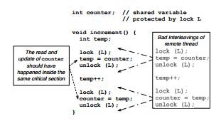

**Works Cited**

1. "Mutex Lock Code Examples (Multithreaded Programming Guide)." Mutex Lock Code Examples (Multithreaded Programming Guide). Oracle Corporation, 2010. Web. 05 Dec. 2016.
2. Lehane. "What Is a Race Condition?" Multithreading - What Is a Race Condition? - Stack Overflow. Stack Overflow, 29 Aug. 2008. Web. 05 Dec. 2016.
3. Zhang, Wei, et al. "ConSeq: detecting concurrency bugs through sequential errors." ACM SIGPLAN Notices. Vol. 46. No. 3. ACM, 2011.
4. Jenkov, Jakob. "Thread Signaling." Jenkov.com. Jenkov.com, 23 June 2014. Web. 05 Dec. 2016.
5. Lucia, Brandon, et al. "Atom-aid: Detecting and surviving atomicity violations." Computer Architecture, 2008. ISCA'08. 35th International Symposium on. IEEE, 2008.